**Advance Excel Assignment 4**

1. To use the ribbon commands, what menu and grouping of commands will you find in the Insert and Delete command?

**Insert & delete are present under home tab.**

**Insert Commands –Home- Insert cells, Insert sheet rows, insert sheet columns, Insert sheet**

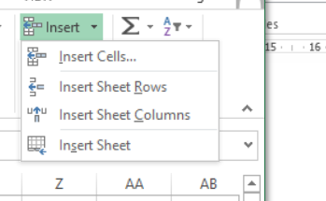

**Insert tab-** **This tab provides options to insert something in a worksheet- a table, a diagram, a chart, a symbol, Pivot table and so on.**

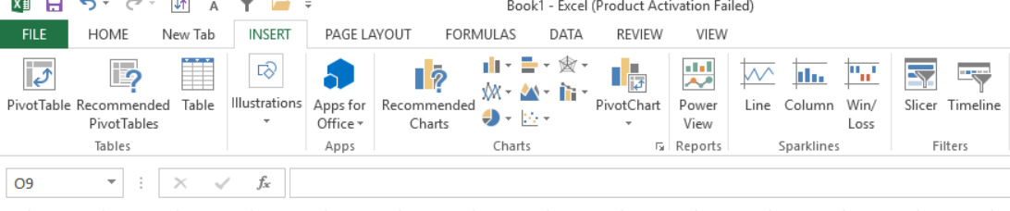

**Delete Commands- delete cells, delete sheet rows, delete sheet columns, delete sheet.**

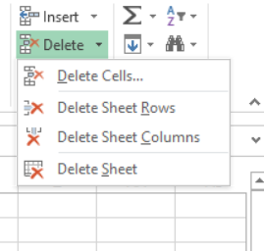

1. If you set a row height or column width to 0 (zero), what happens to the row and column?

**Excel will hide the column or row if we set column height or row height to 0.**

1. Is there a need to change the height and width in a cell? Why?

**Yes, It is necessary to change width and height in excel to fit the data. Excel by default provide equal width and height with respect to columns and rows. Whenever we enter a lengthy data, few characters will get displayed and other will be present inside the cell but will be hidden to the end user.**

1. What is the keyboard shortcut to unhide rows?

**Select the whole sheet & then press Shift + Ctrl + 9 to unhide all the rows in excel.**

1. How to hide rows containing blank cells?
2. **Select the data range which contains the blank cells we want to hide.**
3. **Then click Home > Find & Select > Go To Special**
4. **And in the Go To Special dialog, select Blanks option, and then click OK button.**
5. **All of the blank cells in the selection have been selected.**
6. **Then we can press Ctrl + 9 keys together to hide the rows which have blank cells.**

1. What are the steps to hide the duplicate values using conditional formatting in excel?

**1. Select the data range from which we want to hide duplicate values.**

**2. open the Home tab >> from Conditional Formatting >> go to Highlight Cells Rules >> select Duplicate Values**

**3. A dialog box will pop up. From there select “Format cells that contain”: Duplicate and values with as “Custom Format”.**

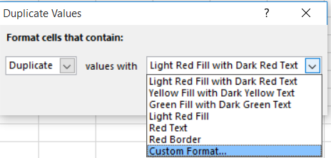

**4. Select white colour from font tab & click ok.**

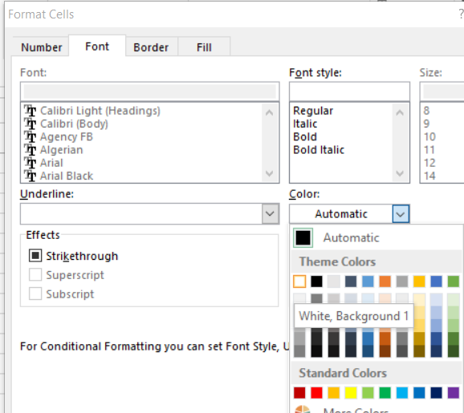

1. **click OK on the first dialog box of Duplicate Values.**

**6. Now, all the duplicates values are hidden.**

